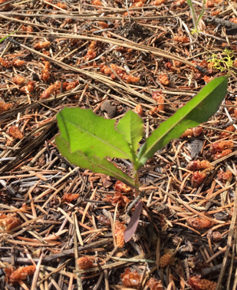

Relative of lettuce (see leaves) and dandelion (see seed heads).

Usually appear as a single stalk; flowers are multiple and yellow.

Most will pull out completely by hand, but *use a glove*, or grasp it just below the soil level to avoid the “prickles”.

They have been spotted all over Wilson Ranch (especially flanking the water inlet to the lake), so they are not hard to find!

It’s best to get to them before they develop their seed heads.

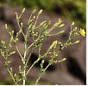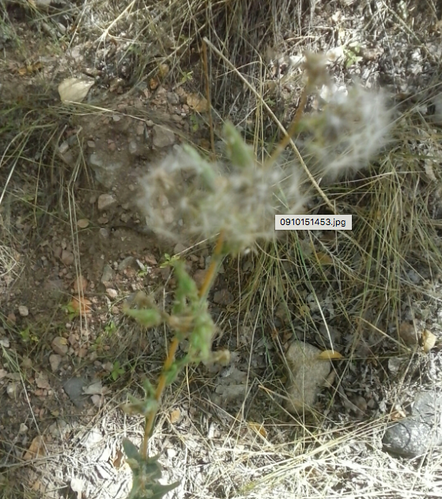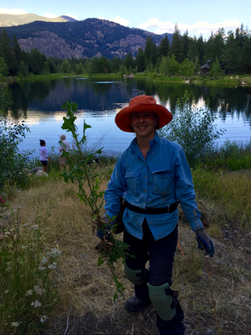

Young plant.

They can grow to over 6 feet tall.

Flower heads.

Seed heads.