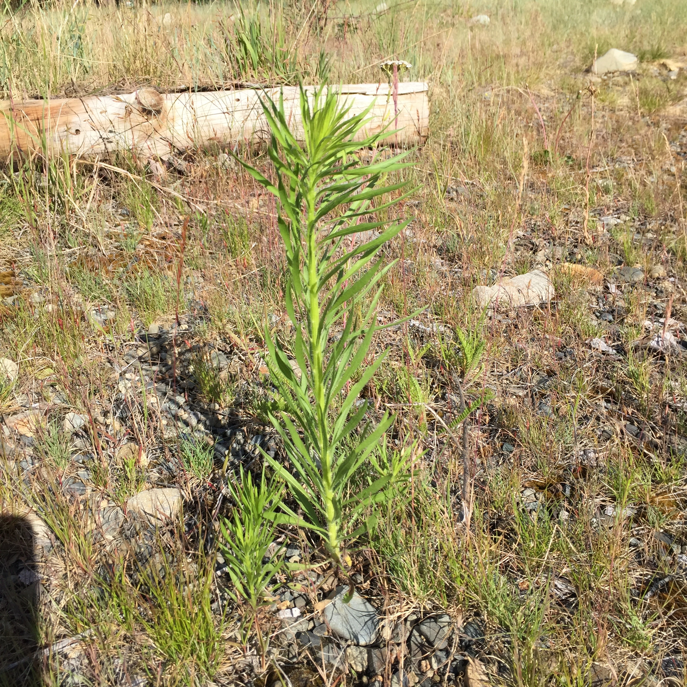

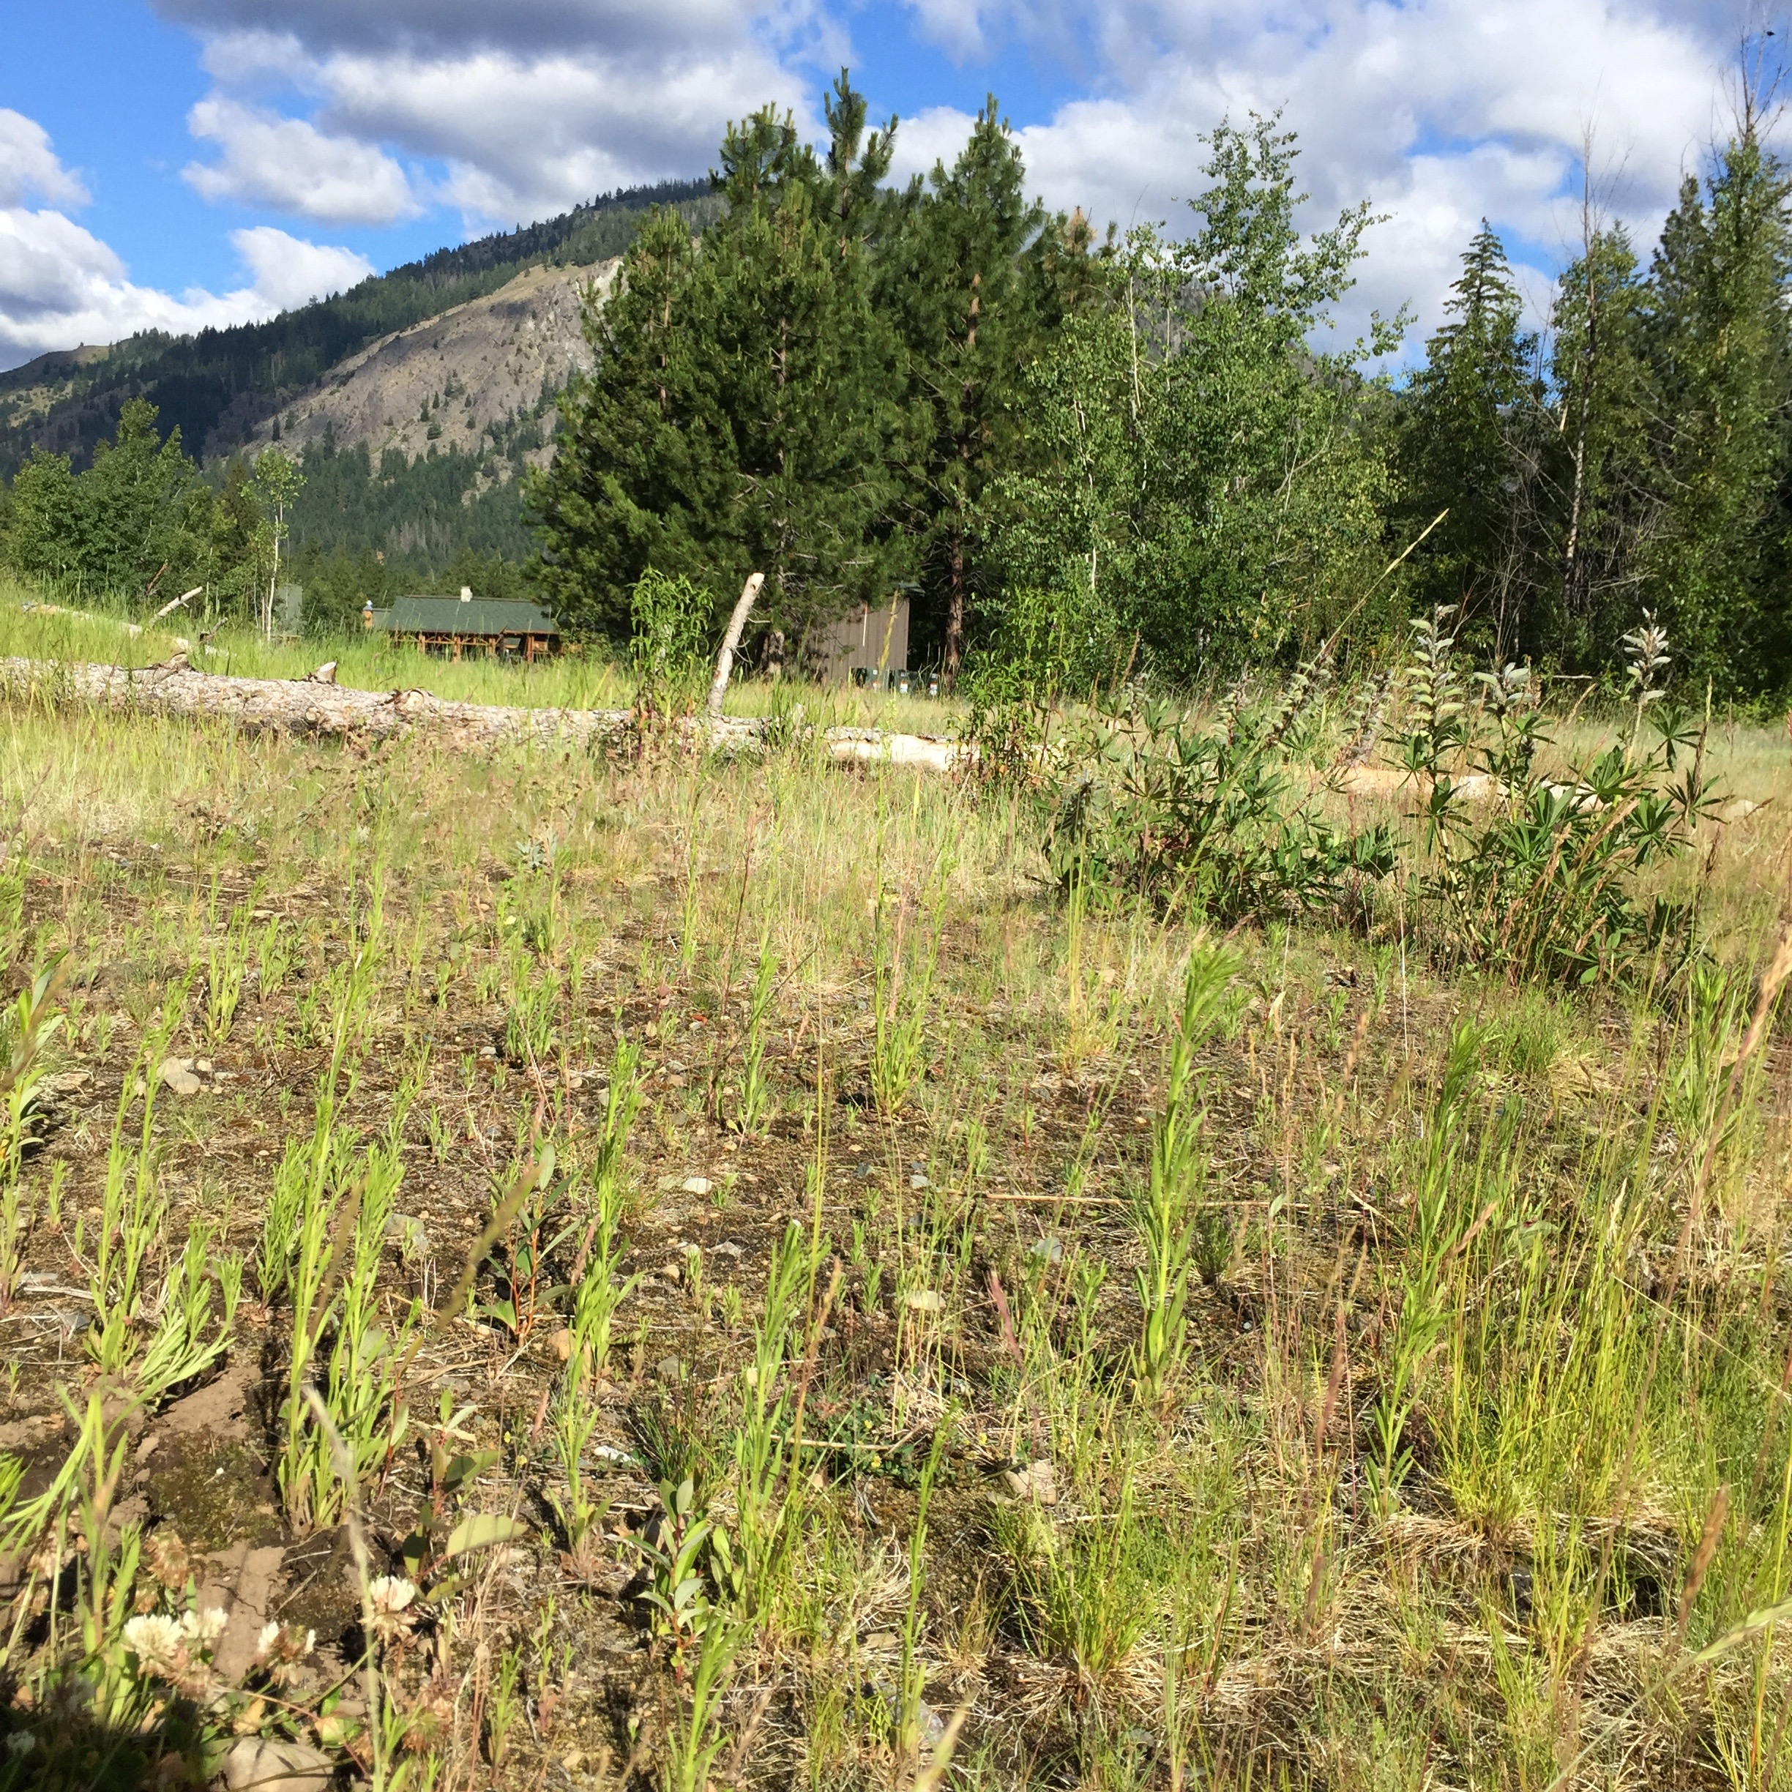

Also called “mare’s tail”.

Usually appear as a single stalk, but can have multiple stalks when previously pulled incompletely.

Very small white daisy-like flowers.

Most will pull out completely manually.

It’s best to get to them before the flowers turn to seed heads.

They have been spotted all over Wilson Ranch, so you are likely to find them outside your door!

Young horseweed

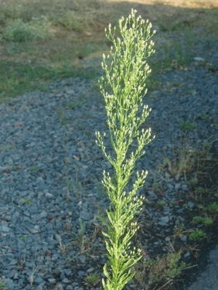 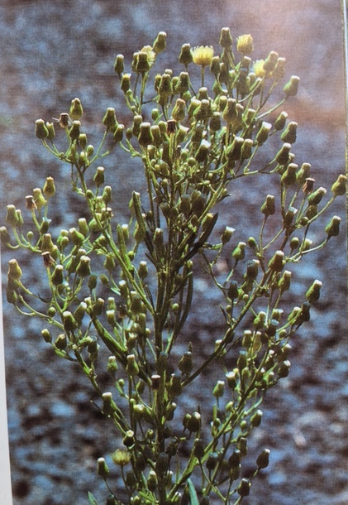

Mature horseweed

Mature daisy-like flower heads