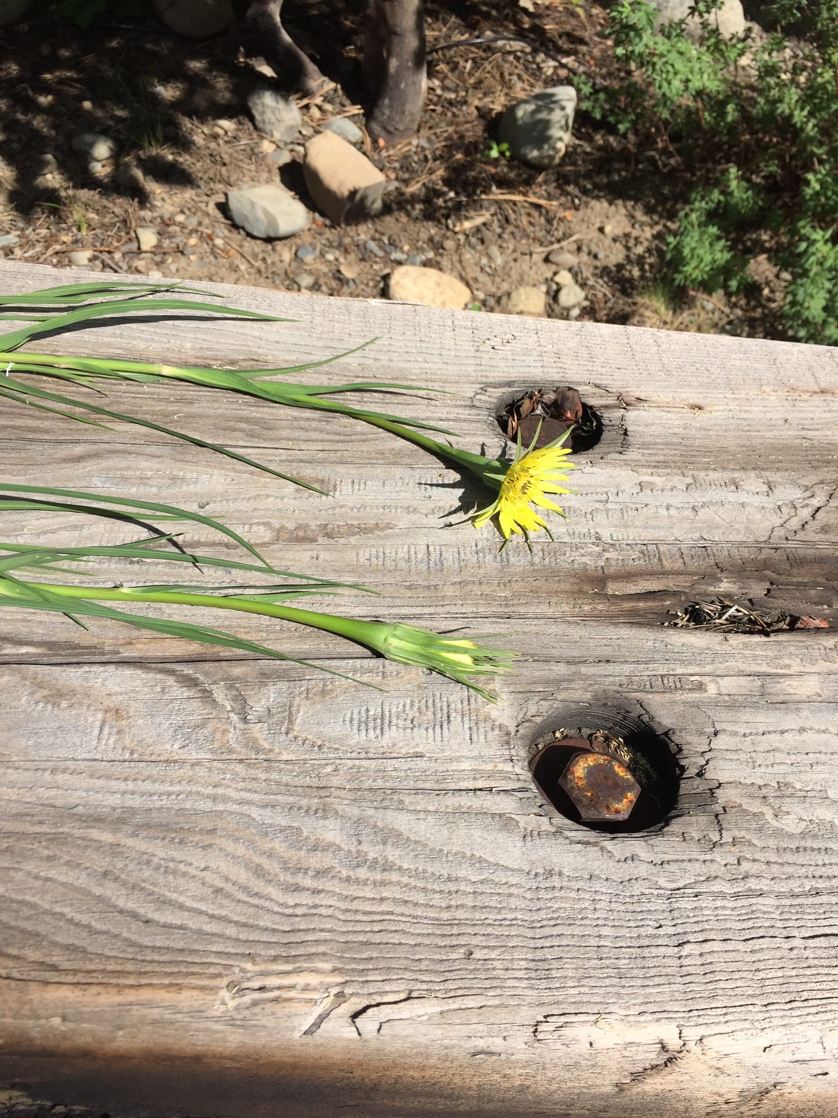

Superficially appear as “glorified dandelions”.

Usually appear as a single stalk, but can have multiple stalks when previously pulled incompletely.

Most will pull out completely by the tap root manually, especially if they are fully developed. If younger, they may break off and re-grow, so use a tool to loosen if needed.

They have been spotted all over Wilson Ranch, so you are likely to find them outside your door!

It’s best to get to them before they develop their giant seed heads (see picture below from *Northwest Weeds* by Ronald Taylor).

